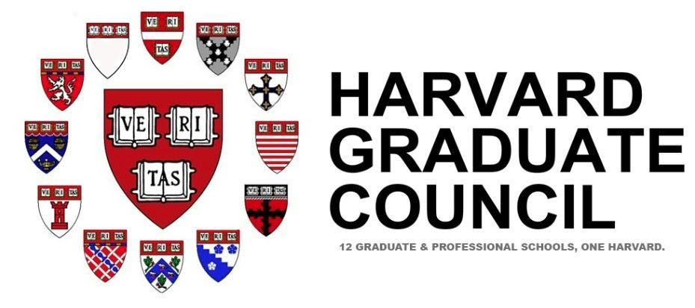
THE HARVARD GRADUATE COUNCIL
The Representative Body for All of Harvard’s Graduate and Professional Students
HGC Executive Board Meeting Agenda
October 2, 2017 7:00 pm-9:00 pm
Sever Hall, Harvard Yard Room 201

Roll Call and Open Forum – Aric (7:00-7:10)
Opening Remarks /Executive Updates– Kevin & Aric (7:10-7:25)
- HUIT Committee
- Inclusion and Belonging/ HILT
Internal Updates Tracie & Kevin (7:25-7:35)
- Welcome and Introduction of elected Chairs and Vice Chairs
Events Updates –Payum, Kevin & La’Toya (7:35-8:10)
Worldwide Week/International Festival
Music Entrepreneurship Conference
Finance Updates – Sam (8:10-8:20)
Budget
Advocacy Updates – Kevin (8:25-8:40)
Discussion on DACA
Information & Communications Updates – Akinwande (8:40-8:45)
Status of Communications & Website

